ASSIGNMENT 7

Summarizing data with Aggregate functions.

1) Write a query that counts all orders for october 3.
Ans--
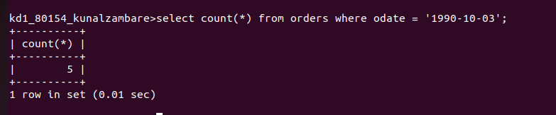

2) Write a query that counts the number of different non-NULL city values in the customers table.
Ans--
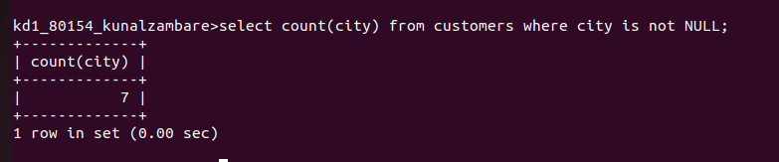

3) Write a query that selects each customers smallest orders.
Ans--
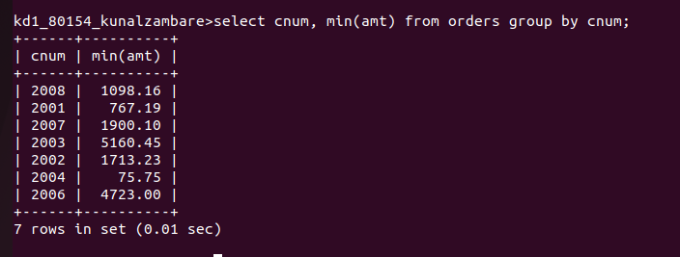

4) Write a query that selects the first customer, in alphabetical order, whose name begins with ‘G’.
Ans--
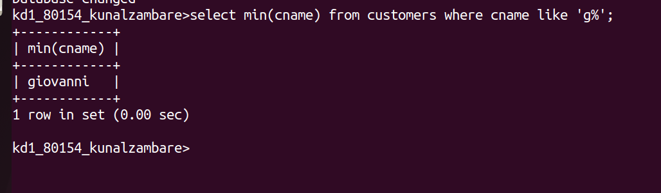

5) Write a query that selects the highest rating in each city.
Ans--
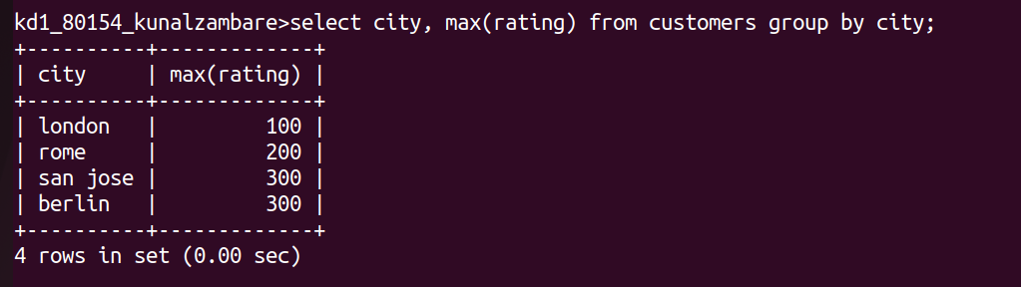

6) Write a query that counts the number of salespeople registering orders for each day.
Ans--
